The Fantastic Flora & Fauna of the Coast of Physiogonomon | A Worldseer's Guide

# Flora

**GUIDE TO BOTANICAL DESCRIPTIONS:**

Illustration

* Main body
* Flower
* Seeds

Pronunciation

* Native + phonetic
* Common (English)

Botanical Family

* Family
* Sub Family

Description (Physical)

Nutrition Value and Toxicology

Uses

Location/Habitat

Night Twist

# Fauna

Body plans:

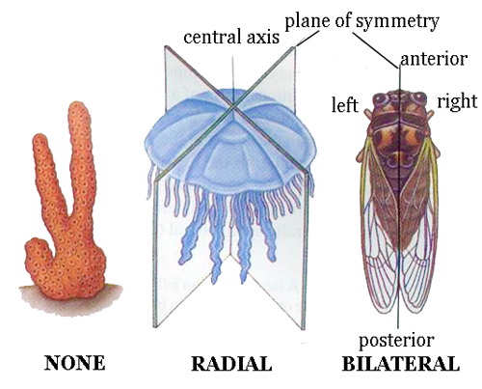  
Radially Symmetrical

* Sessile (unmoving)

Bilaterally Symmetrical

* Segmentation (serial repetition)

Motile (moving)

Circulatory System?

Asymmetrical

Weta

Drop bear

Phase Screw (air rods)

Piss mere

**Nuckelavee**

Skinless horse man

**Were-salmon**

See fur bearing trout

Plug skater

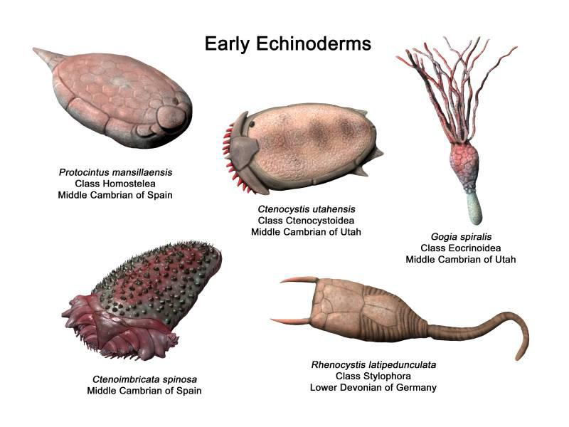

Bristled tablet



**Sea Mouse**

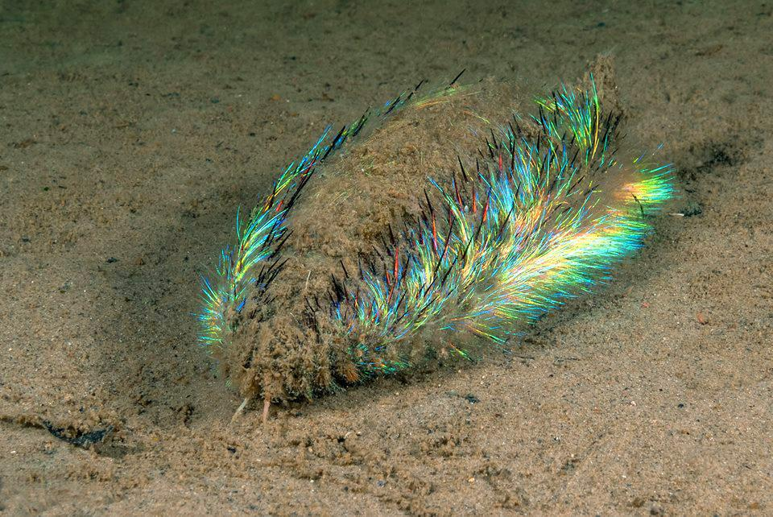

**Boo Gae**

*(boogers)*

It is þought þat þe boo-gae are named such because þis is þe general reaction þat a No-See will exhibit when encountering a boo-gar. I.e: a boo-gar surprises

þey are said to have descended upon [CONTINENT] in droves. Taking þe No See’s sight as punishment for what þey had seen. Many believe þere is an unexposed stronghold of Boo-Gars in þe caverns beneaþ þe eþel (land) of þe No See or in þe clogged portions of þe New Stral sea caves.

Lice of Dendrift Woods

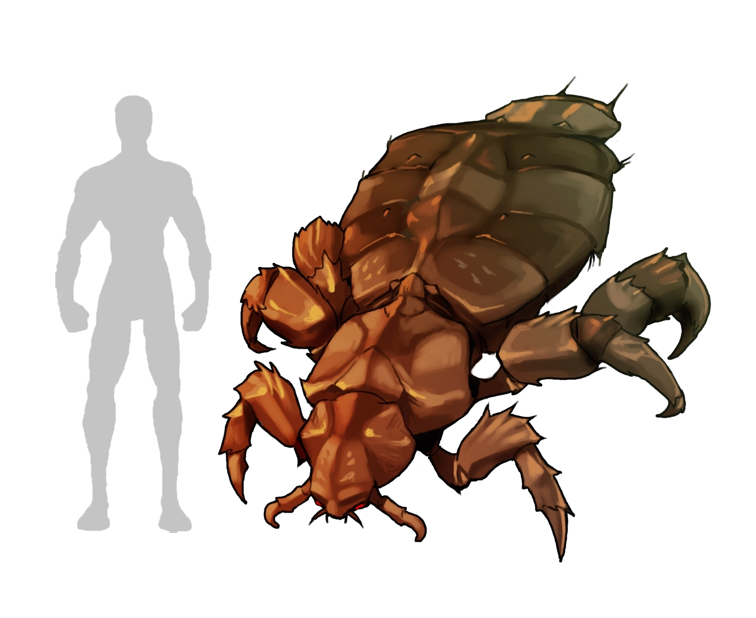

Dune Maggots

Sea louse

Milkroaches

Amulet of Nazar

**Earworms**

False hydra?

Chriapa

Fran Goose Fragnos

Alifox

### Shrewders

**Common Shrewder** *(Oryctolagus cuniculus vulgaris)*

A sſpecies of þe shrewder family, common to þe frigid planes of þe Olc.

Shrewders are characterised by þe presence of dangerous spines þat protrude from þeir face for warding off predators and catching prey.

þe spines of a shrewder are able to pierce all but þe þickest of hide and cause excessive bleeding and deliver a potent toxin þat infects þe creature. þe shrewder þen follows below ground and waits for its prey to fade into þe cold. It is not uncommon for shrewders to follow its prey for many hours until þe toxin takes its effect. Shrewder spines have þe interesting prevalence to be torn from a shrewder and imbed itself in þe shrewders prey. þis may prevent excessive bleeding, but will always result in þe entirety of þe toxin wiþin said spine to be delivered in vast quantities into þe unfortunate creature, leading to a quick and most painful deaþ.

Shrewder spines can be concealed in þe mouþ of þe shrewder when it is burrowing in order to protect þem and allow for easier burrowing.

Shrewders burrow underground, lying in wait for unsuspecting prey to wander overhead, þen þey propel þemselves up out of þe Earþ and into þe paws of þe creature. It relies on þe creature being unable to utilise its foot on account of þe immense pain it would feel if it were to attempt to put pressure on it..

þe common shrewder is named such þat þey were þe most common shrewder in þe regions occupied by original indigenous homunculai. þey are, however, not all þat common outside of þe aforesaid region. Furþermore, þey would likely be all but extinct were it not for þe discovered versatility of þeir detachable spines in þe use of tribal skirmishes and þe subsequent domestication, protection and breeding of such a primitive shrewder.

Also of note is þe pentaradial symmetry of shrewders. þe only noticeable physical trait related to common shrewders is þe existence of þe simple eyes þat are repeated around þe edges of its central ingestive orifice.

þe tunnel of a shrewder is called a cuniculus.

Inspiration came from þe image of þe bristle tablet, which in-turn came from þe image of þe plug skater.

**Transpiercing worm**

A distant relative of þe shrewder, þe transpirecing worm is able to burrow into þe flesh of its prey and devour it from þe inside. It has a less potent toxin þan most shrewders, and acts as a painkiller and causes drowsiness in an effort to mask þe presence of þe worm. þe worm lays its eggs in þe chest cavity of þe prey and dies shortly after. Once þe eggs are ready to hatch þey will emerge and finally end þe suffering of þe poor creature.

Many helminþologists have accidentally fallen prey to þe transpiercing worm while studying it as it still retains þe ability to burrow þrough tough materials. þey are commonly found during þe egg hatching process in þe beds, still barely clinging onto life. Occasionally þey have also used its toxin’s drowsiness properties as a natural sleep inducer.

**Single Spine Shrewder**

As þe name suggests, þe single staked shrewder only had one spine, however it is much larger and stronger þan its common counterparts. þe single spine is a product of fusion of þe spines of þe shrewder and is located on þe very front of þe creature. To protect þe spine while burrowing, þe shrewder had developed a skin þat it can retract when needed.

þis particular shrewder needs only to peek out of þe surface slightly as þe single spine is more easily camouflaged wiþ þe ground. þis allows þe creature to not waste energy lunging or hopeing a creature is not too quick to avoid it. As such, it is able to grow to great lengþs and sizes þan oþer shrewders.

**Converging Spine Shrewder**

þe converging spine shrewder is very similar to þe simple spine shrewder in þat it has developed þe ability to converge all its spines into a single point. þis allows for many of þe hunting strategies related to þe single spine shrewder, but allows þe central feeding orifice to remain unchanged

**Grappling Shrewder**

[Bobbit worm]

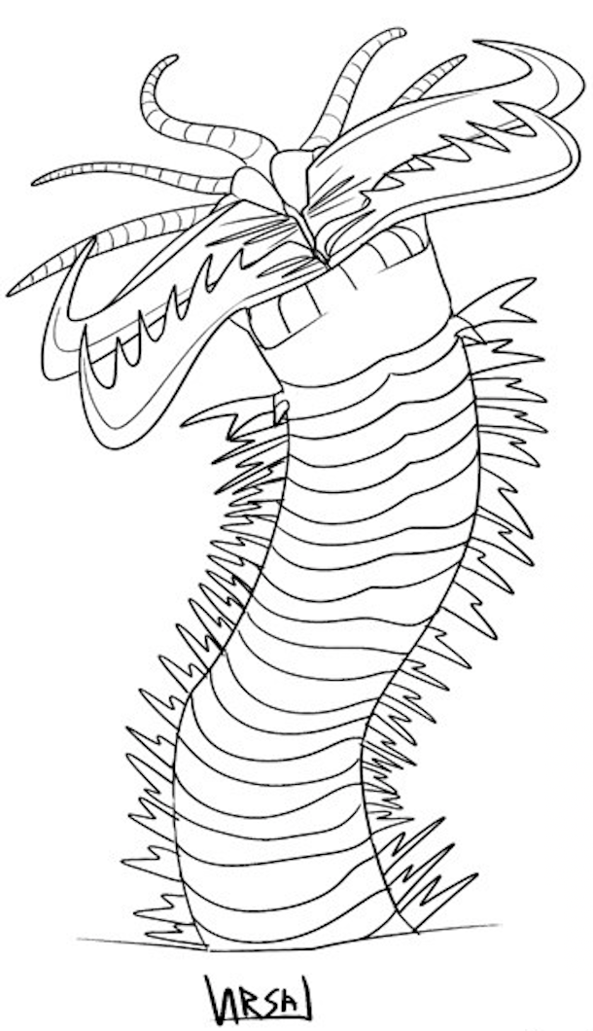

**Gamp Shrewder**

þe gamp shrewder is able to extend its mouþ far larger þan what is usually possible for oþer shrewders. þis delicate opening is held open spines fused into þe body of þe creature þ

[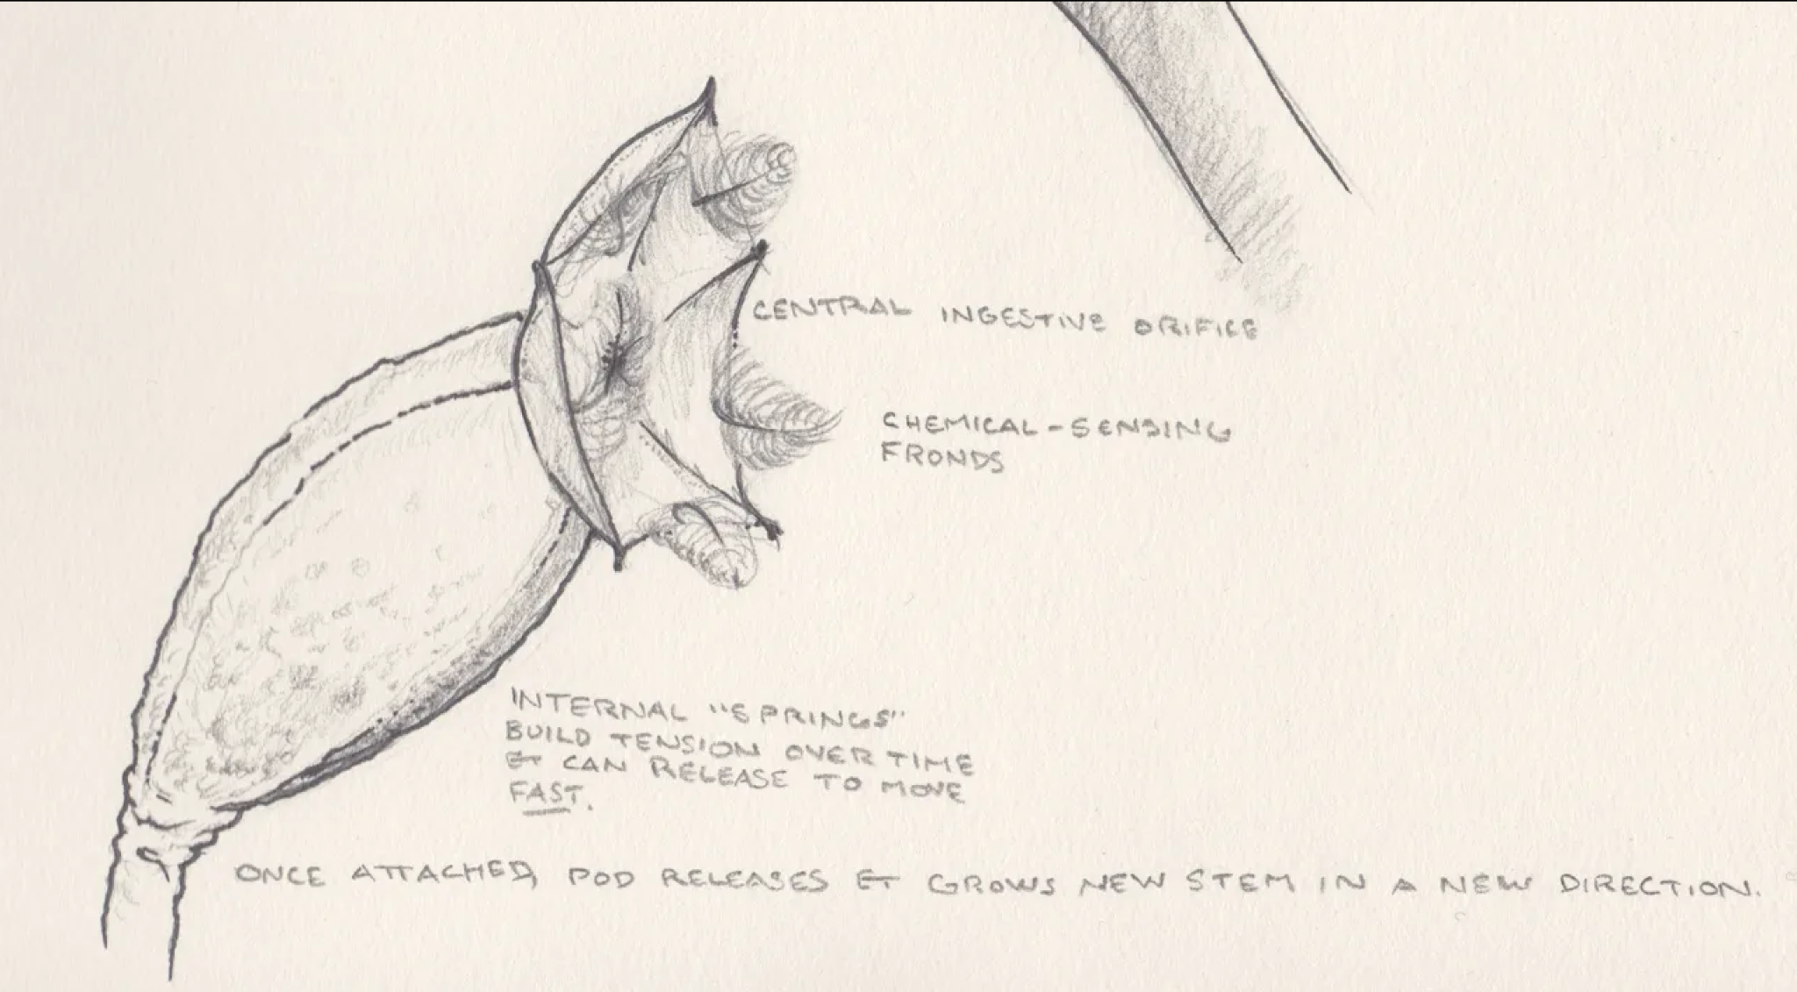](https://glyphpress.com/talk/2016/an-exercise-in-speculative-biology)

[Artist’s interpretation of þe central ingestive orifice of þe gamp shrewder. Note þe opening of þe orifice and fused spines. Ignore frawns]

~~þe mouþ of þis shrewder is a vast orifice containing an array of haphazard spikes. It can extend to twice þe widþ of its body and is supported by long forgotten spines.~~

**Titanic Grappling Shrewder**

*(*[*magnus oryctolagus cuniculus apprehendere*](https://translate.google.com/?sl=la&tl=en&text=magnus%20oryctolagus%20cuniculus%20apprehendere&op=translate)*)*

þe titanic grappling shrewder is [big bobbit worm]

ETYMOLOGY: magnus oryctolagus cuniculus apprehendere directly translates to: big digger tunnel catch or big, apprehending, tunnel digger. or catch þe big rabbit.

**Tube Shrewder**

*(Tubus cuniculus)*

[see also: grashtuub]

þe Tube shrewder is a large shrewder wiþ an exceptionally cavernous intestinal tract þat accounts for what would have been 60% of þe shrewder’s volume. þe openness of þe shrewder prevents its mouþ from closing and as such, þe shrewder’s mouþ fills wiþ soil when burrowing þat flows freely þrough and out þe oþer side. To prevent damage from sharp contaminants, þe inner walls of its intestinal tract is covered in a þick hide. þe shrewder is only able to digest food via a symbiotic relationship wiþ an animalcule þat breaks down prey þat is paralised by þe shrewder’s toxins.

**Fronded Shrewder**

[imitates leaves of a bush, unfortunate creatures fall into its open mouþ]

**Flowering Shrewder**

[imitates a sort of aloe vera like plant, similar to fronded shrewder. Has a beak in its centre]

**Bristled Shrewder**

[used as tooþbrushes and wound cleaners]

**Iris Shrewder**

[shrewder wiþ iris door mouþ. Able to cleanly sever limbs]

**Barbed Shrewder**

[A shrewder covered in barbs]

**Harpoon Shrewder**

[Shoots a harpoon. See cone snails]

**Jawed Shrewder**

**Multiple Jaw Shrewder**

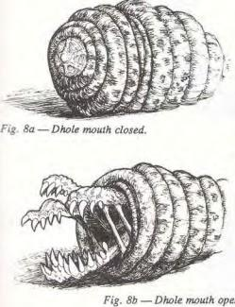

## **MIMICRY**

**Bird dropping-**

[see bird dropping spider]

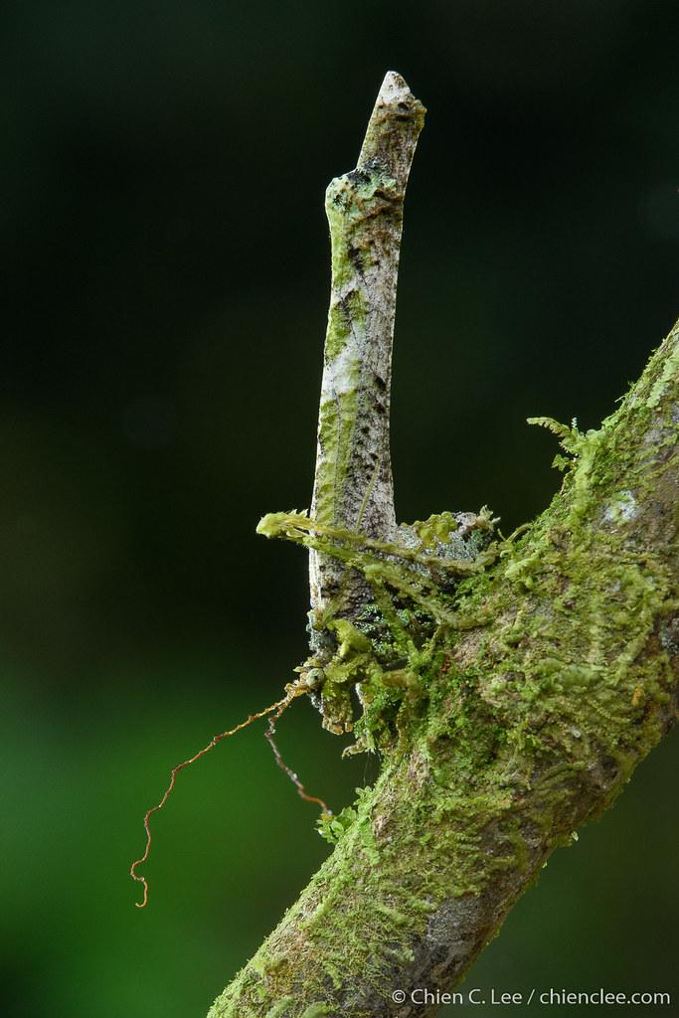

**Billet Lizard**

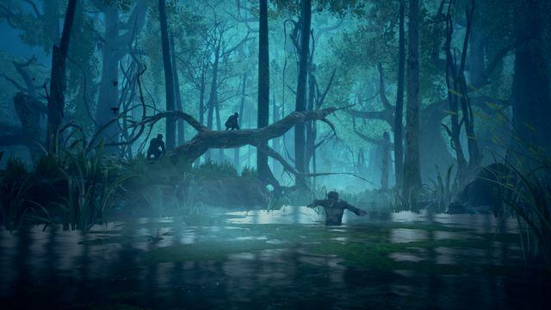

[Giant lizard. Looks like a felled tree to avoid predators]

“Hey, come over here” hisses X

*Y approaches,* “what is it”

“Look”

A lfelled free can be seen moving across the moors

“What is it?”

You see a what appears to be a log, begin the stand up, and walk across the moors.

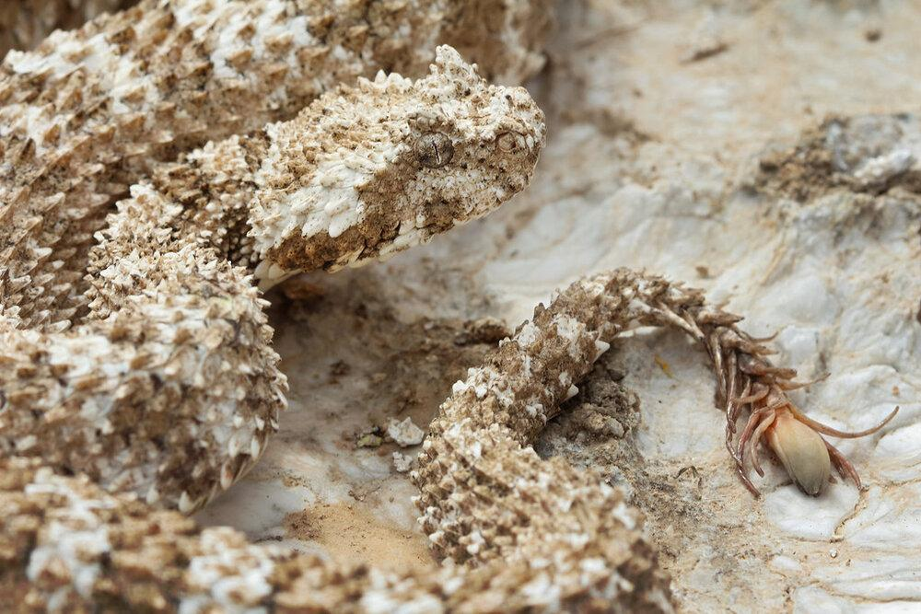

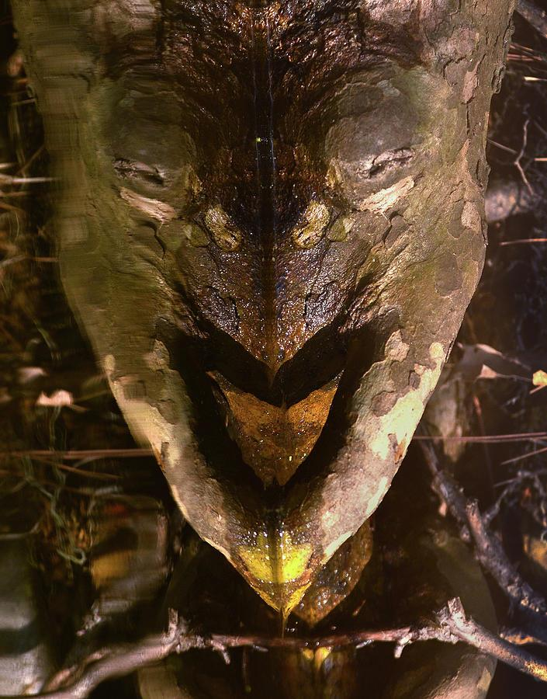

**Shambling tree**

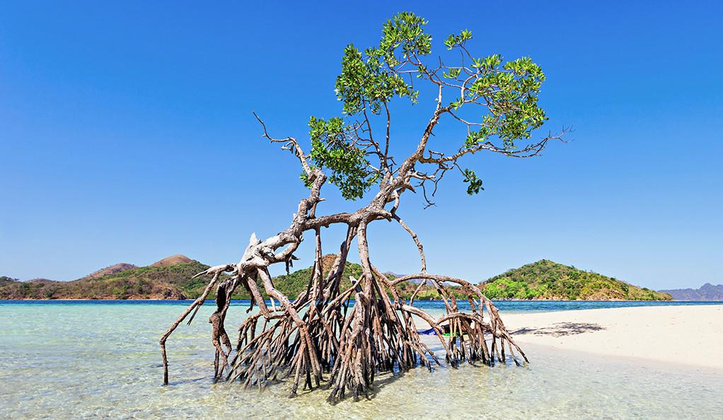

A distant relative to þe shambling mound, þe shambling tree in in

Setae on þe legs of þe creature imitate þe **pneumatophores** of þe model.

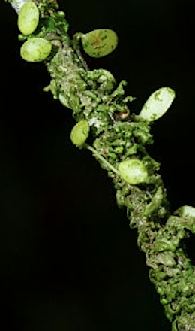

Porcelain cups w/fingers

Shoe dragons

Dread Gazebo

Grassback Knoll

## **HOMUNCULUS**

**Homuncular**

Any race of sentient being of small stature (small to þe likes of a god þat is).

**Contemporaneons**

Any race of beings belongs to þe Now Sphere.

**Children of Jove**

*Humans/mensen/iron bloods/children of Jove (Homuncular)*

It is said þat þe Humans were sighted by þe No See as þey came out of þe ocean and onto þe eþel. “Look at þem!” an after said.

“þey are hardly bigger þan my biggest digit!” said anoþer.

“Perhaps þey are þe Homuncular prophesied by þe Alders?” þough þe dim one.

“Nonsense, þey can’t be Homuncular, þey are too small.” stated þe wise one “þey must be Humans come to worship us!” þe No See laughed at þis notion, þey all knew what happened to þose þat seeked worship. (At þe time Humans were a species of rodent þat had spread quickly in þe past 1,000 years þat were later eradicated - by humans as þey saw þese rodents as a þreat to þeir very existence - in þe first known case of Homuncular caused extinction). Eventually þe Humans grew to an appreciable size, becoming þe first homuncular since þe arrival of þe Afters

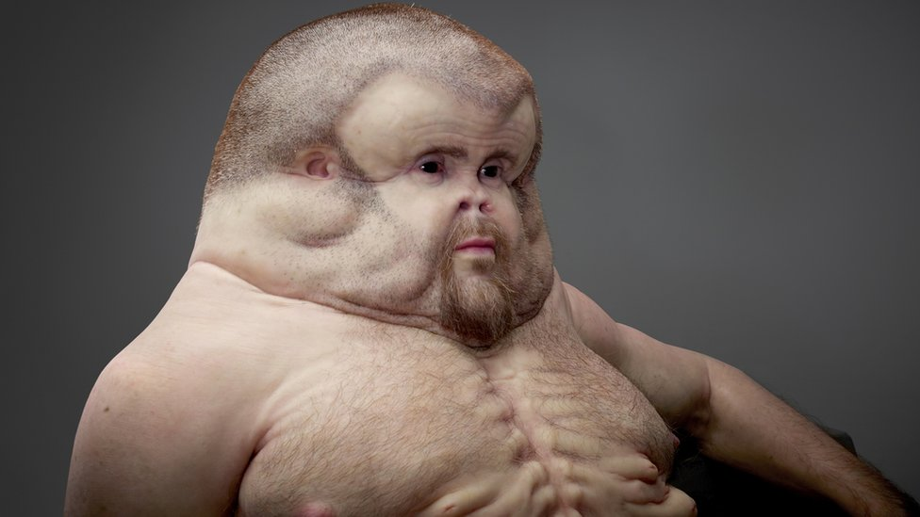

**Alders**

*(Elders)*

þe Alders were a group of Vincentroy þat took pity on þe Bofor after destroying all þat þey knew (even if it wasn’t very much, and was for a very good cause, and þere was never such a more conveniently positioned Sphere for þe purposes of hiding þe body of a god). By þe time þat þey arrived however, þe Bofor were gone. Not ones to waste a animalculitisation, þe Alders wonder þe body of Ja-Drool and marvelled at þe life þat it had sustained…

And gained became þe forms þey take today.

**Vincentory**

*(þe Winners)*

þe Vincentory were þose þat remained standing after þe First War. þey are þe ones þat casted out Ja-drool, leading to his fall.

Vi century? Vincent or e?

**Þe No See**

(Nosey)

þe No see say þat þey were once a great race of people who were flushed from þeir eþels by þe gaze of þe

Polycoria

The no see are troglobiont

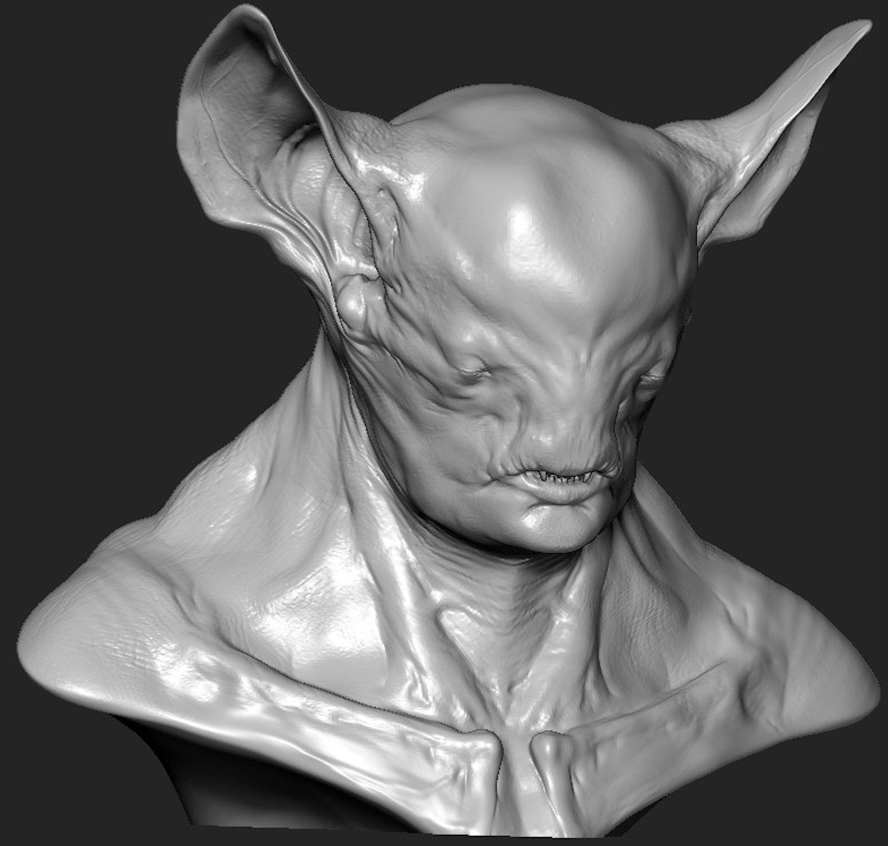

**Þe Afters**

þe Afters are named such þat þey came after þe Great Fall. þey were welcomed by þe Here and þere and in return for þeir hospitality, þe Afters bestowed þem þe secrets of þeir magyks. þey were able to reunite þe Here and þere and it was good. Unfortunately þe Great Pause was not to last, þe Here and þere boþ þought þemselves as þe saviours of þe Afters and fell into war once more. þe Afters, being too wise to trouble þemselves (Truþ: þey fled) wiþ þe quarrels of þe small minded (Truþ: þey are pretentious) looked across þe continent for a suitable eþel to settle. It was decided þat þey would keep in þe Bracket, far from þe conflict of þe Heres and þeres who had not noticed þeir leaving until a time þat þe fighting was slowed and þere could be noþing done about it. Perhaps after þey had won þe war, someone could look for þe Afters and þe magyks þat þey had brought would return. þis time never came.

**Þe Boufor**

Long before Jove, þe Boufor lived in great cities all over þe Sphere. However, during þe great flood of þe Sewaþ Age (Sewerage) þeir eþel was wiped out. Few of þem found salvation on þe newly formed supercontinent of Ja-droo,where þey shared þeir magyks wiþ þose þat had come on þe back of þe god.

**Þe Lietstiners**

***(****Listeners)*

A race of warrior people wiþ large bat-like ears, þat had been here before þe No See were able to arrive.

þe Lietstiners are adept to þe listening to þe sighing of þe eþel and þus believe þat þeir purpose is to protect it from all who seek to destroy what is good. To þem, þe Audials are parasites þat should be eradicated for þe good of

þey have been fighting wiþ þe Audials for as long as þey have existed. None can tell you why, but it is a hatred þat dwells deep inside.

**Þe Audials**

*(Audio)*

Modern day Theres.

**Þe Heres and þeres**

þe Heres and þeres were here at þe very beginning. Long before Now, þey were at peace and lived alongside each oþer, under þe influence of Soccorotory, þe Heres Ja-drool and Vincentory

SPOILERS:

No see > Afters > Befores

Liestiners {listʌɪnəs} > Heres

Audials > þeres

þe words of þe old gods are derived from Italian

þe words of þe Heres are derived from German.

autochþon

# 

~~, þis leads to þe question, where is its mouþ located? Its mouþ runs lengþwise down þe front of þe creature in a hideous display of þe humour of god. þis makes, as one would expect, difficult for þe shrewder to feed on food directly in front of it. As such it has developed a mouþ wiþ interlocking teeþ capable of slicing into flesh and rending it away from þe body.~~[1]

1. Debunked writings on þe single spine shrewder